Project Design Phase-II
Data Flow Diagram & User Stories

Date | 18 June 2026
Team ID
Project Name | ShopEZ – MERN Stack E-Commerce Platform
Maximum Marks | 4 Marks

Data Flow Diagrams:
A Data Flow Diagram (DFD) is a traditional visual representation of the information flows within a system. A neat and clear DFD can depict the right amount of the system requirement graphically. It shows how data enters and leaves the system, what changes the information, and where data is stored.
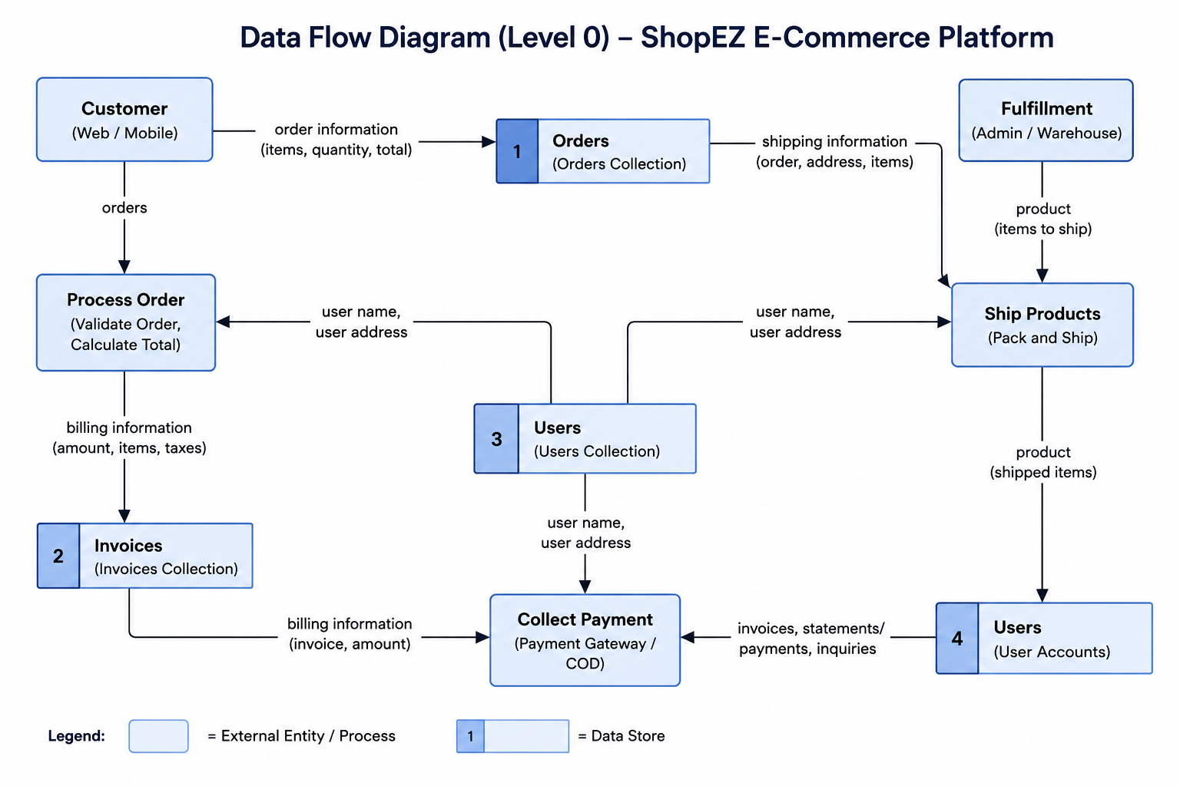
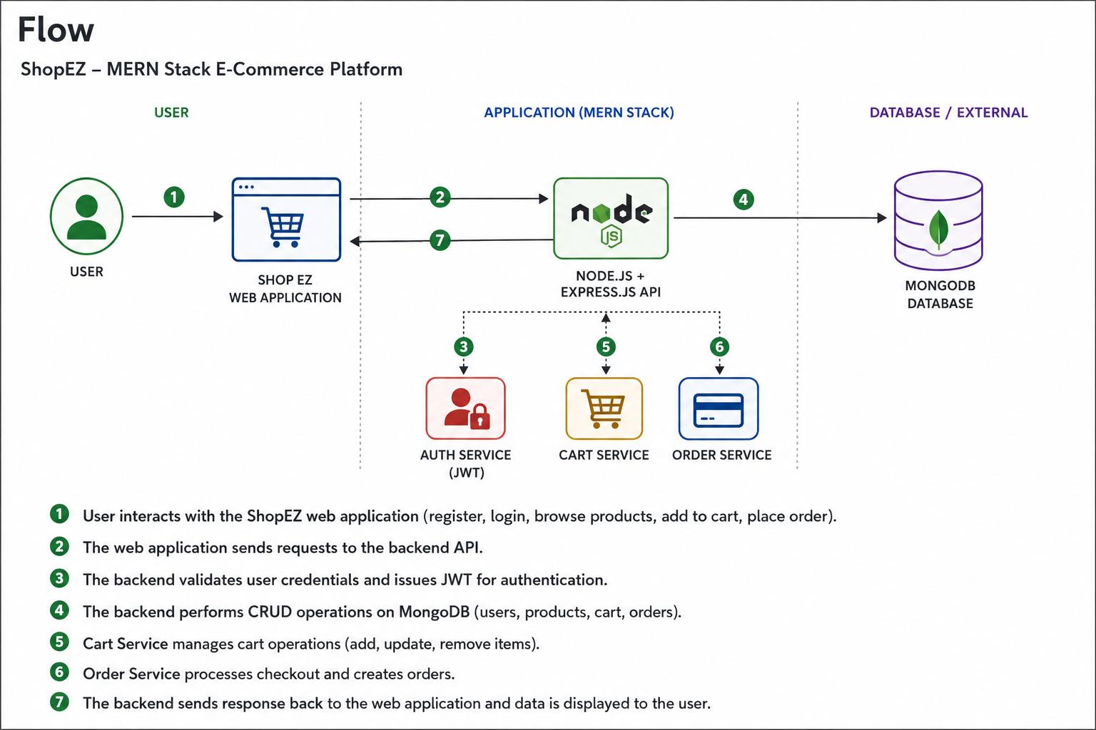

User Stories
Use the below template to list all the user stories for the product.
User Type | Functional Requirement (Epic) | User Story Number | User Story / Task | Acceptance criteria | Priority | Release
Customer | Registration | USN-1 | As a user, I can register with email and password. | User account created successfully. | High | Sprint-1
Customer | Login | USN-2 | As a user, I can login securely. | User can access dashboard. | High | Sprint-1
Customer | Products | USN-3 | As a user, I can view products. | Products displayed correctly. | High | Sprint-2
Customer | Search | USN-4 | As a user, I can search products by name. | Matching products displayed. | High | Sprint-2
Customer | Categories | USN-5 | As a user, I can browse products category-wise. | Products grouped by category. | High | Sprint-2
Customer | Cart | USN-6 | As a user, I can add products to cart. | Product added successfully. | High | Sprint-3
Customer | Cart | USN-7 | As a user, I can increase or decrease quantity. | Cart quantity updated. | High | Sprint-3
Customer | Cart | USN-8 | As a user, I can remove products from cart. | Item removed successfully. | High | Sprint-3
Customer | Orders | USN-9 | As a user, I can place orders. | Order created successfully. | High | Sprint-4
Admin | Product Management | USN-10 | As an admin, I can add products. | Product saved in database. | High | Sprint-4
Admin | Product Management | USN-11 | As an admin, I can edit products. | Product updated successfully. | High | Sprint-4
Admin | Product Management | USN-12 | As an admin, I can delete products. | Product removed successfully. | High | Sprint-4
Admin | Product Images | USN-13 | As an admin, I can add product image URLs. | Images displayed on product page. | Medium | Sprint-4

